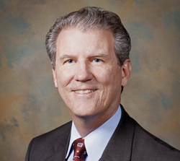

Biography of Patrick Carter, M.D.
Dr. Patrick Carter is Medical Director for Care Coordination and Quality Improvement for KelseyCare Health Plans and Kelsey-Seybold Clinic. He also serves as Department Chair of Kelsey-Seybold’s Family Medicine department. In both roles, he supervises the care delivered by Kelsey-Seybold physicians. He cares for patients at the Kelsey-Seybold Main Campus near the Texas Medical Center. Dr. Carter is a Clinical Associate Professor of Family and Community Medicine at Baylor College of Medicine in Houston. He is board certified in Family Medicine with a subspecialty in geriatric medicine. He is also certified as a Physician Executive by the American College of Physician Executives. Dr. Carter attended Rush Medical College and holds a Master’s degree in Business Administration from Stanford University.

